 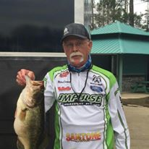

## September 10, 2016

## Papa's on the Lake - Lake Conroe

***$150.00 Entry Fee per Team***

***Optional Big Bass Pot $20***

# Team Bass Tournament Benefitting the Family of Mike Conaway

## 

**Mail Entries and Make Checks Payable to:**

**Katy Bassmasters**

Richard McGehee, President

21414 Park Willow

Katy, Texas 77450

281.384.1184

A late Registration will be held on Friday, September 9, 2016 from 6pm-8pm at Papas on the Lake. The entry fee will be $175.00 at late registration.

An optional Big Bass Pot will be $20 per team with 100% payout to single Big Bass.

This will be a team tournament format. We will begin at safe light and you must be checked in at 3:00pm. Take off order will be determined by entry date.

There will be an auction and raffle with many great prizes. Thank you to our sponsors who have donated many great prizes.

45% of all proceeds will be given directly to Mike’s family.

*The remainder of the proceeds will be split up as follows:* 50% prize money/5% expenses

Michael Conaway was a member of the Katy Bassmasters Club and BASS.

In February, while competing in a BASS Federation tourney on Lake Conroe, he lost his life in a boating accident. He leaves behind a wife and family. You can find more of his story on the Texas Bass Federation site on the internet.

The Katy Bassmasters is sponsoring this tournament in his memory and to help the family with expenses.